***CST2120 Coursework Report***

***E-COMMERCE WEBSITE***

***M00779169***

***Jan Ciepiela***

The main page of my website features the products available for order. Users can select the products (in my case hats) they want to buy and add them to the basket by clicking the shopping cart icon.

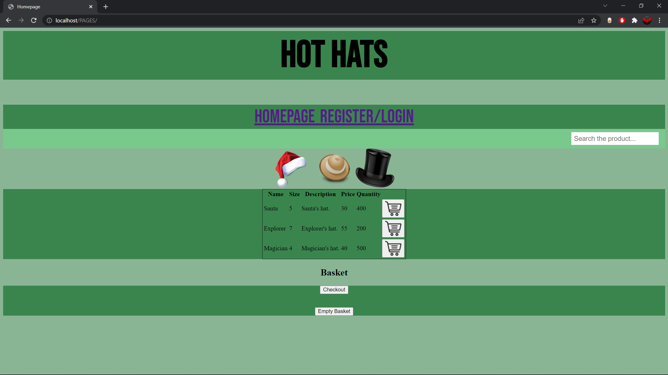

After clicking the shopping cart icon, the script is invoked which adds products to the basket below.

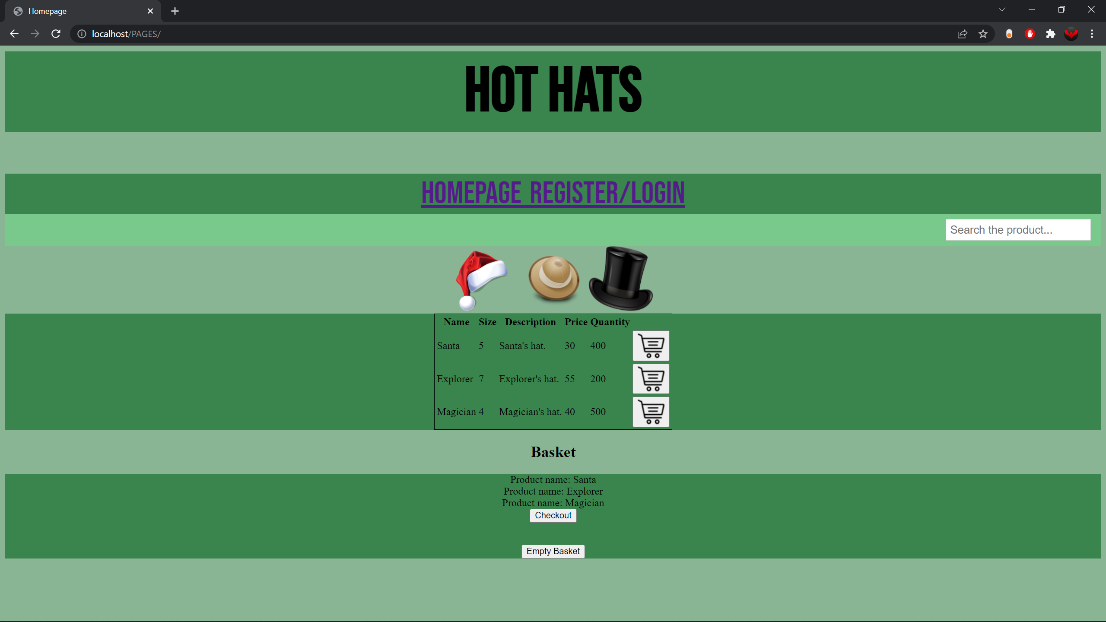

We can empty the basket with neat “Empty basket” button.

If customers decide to buy the selected product, they can proceed to the checkout by clicking “Checkout” button.

Customer may now enter the details and confirm the purchase, which results in adding the order to the Orders collection of our database.

By clicking “Register/Login” option on the navigation bar on the main page we can access the registration page where users can enter create their accounts and log in. For registration process I have used a very basic AJAX so that the response from the server is displayed in the div container and user is thanked for the registration.

The next part of my project website consists of a Content Management System that administrators can use to control the contents of my e-commerce page.

CMS allow us to add products to the website (meaning, adding documents to the database) as well as deleting said products. We may also list all the products available and edit certain details regarding each product. When customer confirms purchase, orders are saved to the database and through our CMS we can access those orders and delete them if we wish.

***ADDING PRODUCTS***

***VIEWING ALL PRODUCTS***

***EDITING PRODUCTS***

***DELETING PRODUCTS***

***ORDERS MANAGEMENT***

There is also a separate management section for managing customers’ accounts.

***ADDING CUSTOMERS’ ACCOUNT***

***DELETING CUSTOMERS’ ACCOUNT***

***FINDING CUSTOMERS’ ACCOUNT***

***REPLACING CUSTOMERS’ DETAILS (EDITING)***

Alas there are many ways in which my website could be extended, more complex use of AJAX would refine it as well as paying more attention to the CSS and attractiveness of the front end. I think database management was alright and I understood how it works. I did not have enough time to make the stock count of the products, which would make the e-commerce website more realistic. I also failed to implement the search functionality and keywords for products in database which is essential for a good page. All in all, I did what I could in given time and without the help of my teammates.